**Table 1:** Landscape attributes, diversity and aggregation estimates for epifaunal taxa in nine eelgrass meadows in Barkely Sound. Fetch was estimated by calculating the distance to nearest land from the eelgrass meadow in 10 degree increments around a centroid point and summing the distances. Diversity at the site level is reported as the number of epifaunal species (30 possible taxa, Table 2) observed in each meadow (γsite) and diversity (Rsite) estimated from extrapolated rarified estimates to 2x minimum following Chao et al (2014). Estimates of spatial aggregation (Im) for epifaunal species (mean + se) with significant aggregation across species are indicated in bold (95% CIs do not include 0.5). The proportion of species present in the meadow with significant I values based on Χ2 tests is also given.

|  |  |  |  |  |  |  |
| --- | --- | --- | --- | --- | --- | --- |
| **Site name** | **Abbr.** | **Fetch (km)** | **Diversity** | **Aggregation** | **Diversity** | **Proportion of species with significant I** |
| **(γsite)** | **(Im)** | **Rsite** |
|  |  |  |  |  |  |  |
| Dodger Channel | DC | 32.05 | 17 | 0.47 | 18.2 | 91 |
| (0.34 – 0.59) | (10.0, 26.4) |
|  |  |  |  |  |  |  |
|  |  |  |  |  |  |  |
| Wizard Islet | WI | 50.53 | 18 | 0.41 | 19.8 | 83 |
| (0.25 – 0.57) | (11.5, 27.8) |
|  |  |  |  |  |  |  |
|  |  |  |  |  |  |  |
| Bald Eagle Cove | BE | 58.97 | 17 | 0.5 | 22.2 | 90 |
| (0.34 – 0.65) | (4.78, 39.7) |
|  |  |  |  |  |  |  |
|  |  |  |  |  |  |  |
| Ellis Island | EI | 97.17 | 13 | 0.44 | 12.3 | 82 |
| (0.28 – 0.60) | (7.6, 16.9) |
|  |  |  |  |  |  |  |
|  |  |  |  |  |  |  |
| Robber's Passage | RP | 50.55 | 22 | **0.57** | 29.4 | 93 |
| (0.51 – 0.64) | (19.6, 39.2) |
|  |  |  |  |  |  |  |
|  |  |  |  |  |  |  |
| Numukamis Bay | NB | 68.72 | 16 | 0.46 | 19 | 88 |
| (0.28 – 0.64) | (10.7, 27.3) |
|  |  |  |  |  |  |  |
|  |  |  |  |  |  |  |
| Crickitt Bay | CB | 24.85 | 14 | 0.53 | 14 | 89 |
| (0.37 – 0.69) | (9.0, 20.0) |
|  |  |  |  |  |  |  |
|  |  |  |  |  |  |  |
| Boyson Islands | BI | 51.59 | 17 | 0.38 | 17 | 77 |
| (0.21 – 0.55) | (12.4, 21.6) |
|  |  |  |  |  |  |  |
|  |  |  |  |  |  |  |
| Crow Cove | CC | 29.41 | 10 | **0.23** | 9 | 67 |
| (0.03 – 0.40) | (8.0, 10.9) |
|  |  |  |  |  |  |  |

**Table 2:** Relative abundance of epifaunal taxa in each meadow in May (M), June/July (J), and August (A).Numbers indicate the rank of abundances relative to other species observed in that meadow at that time. Species with significant spatial intraspecific aggregation within the meadow, estimated as Morisita’s Index, are indicated in bold. Significance determined by chi-squared tests and P < 0.05. Grazers indicated with *.

|  |  |  |  |  |  |  |  |  |  |  |  |  |  |  |  |  |  |  |  |  |  |  |  |  |  |  |  |  |  |  |  |  |  |  |  |  |  |  |  |  |  |  |  |  |  |  |  |  |  |  |  |  |  |  |
| --- | --- | --- | --- | --- | --- | --- | --- | --- | --- | --- | --- | --- | --- | --- | --- | --- | --- | --- | --- | --- | --- | --- | --- | --- | --- | --- | --- | --- | --- | --- | --- | --- | --- | --- | --- | --- | --- | --- | --- | --- | --- | --- | --- | --- | --- | --- | --- | --- | --- | --- | --- | --- | --- | --- |
| **Species** | | **T** | |  | | **DC** | | | | | |  | | **WI** | | | | | |  | | **BE** | |  | | **EI** | |  | | **RP** | | | | | |  | | **NB** | | | | | |  | | **CB** | | | | |  | **BI** |  | **CC** |
|  | |  | |  | |  | |  | |  | |  | |  | |  | |  | |  | |  | |  | |  | |  | |  | |  | |  | |  | |  | |  | |  | |  | |  | |  | |  |  |  |  |  |
|  | |  | |  | | **M** | | **J** | | **A** | |  | | **M** | | **J** | | **A** | |  | | **J** | |  | | **J** | |  | | **M** | | **J** | | **A** | |  | | **M** | | **J** | | **A** | |  | | **M** | | **J** | | **A** |  | **J** |  | **J** |
| ***Crustacean*** | |  | |  | |  | |  | |  | |  | |  | |  | |  | |  | |  | |  | |  | |  | |  | |  | |  | |  | |  | |  | |  | |  | |  | |  | |  |  |  |  |  |
| *Caprella* spp.* | | 1 | |  | | 1 | | **1** | | 2 | |  | | 9 | | **5** | | 2 | |  | | **1** | |  | | **4** | |  | | 1 | | **1** | | 2 | |  | | 11 | | 11 | | 6 | |  | | 3 | | **6** | | 4 |  | 14 |  | 4 |
| *Aoroides columbiae\** | | 7 | |  | | 2 | | **2** | | 3 | |  | | 5 | | 11 | | 7 | |  | | 10 | |  | | **6** | |  | | 3 | | **8** | | 5 | |  | | -- | | 7 | | 8 | |  | | -- | | **7** | | 13 |  | **8** |  | -- |
| *Pentidotea resecata* | | 8 | |  | | 4 | | **4** | | 5 | |  | | 7 | | **3** | | 5 | |  | | **3** | |  | | 11 | |  | | 6 | | **9** | | 8 | |  | | 1 | | **3** | | 4 | |  | | 2 | | **5** | | 8 |  | **6** |  | 5 |
| *Leptochelia dubia* | | 9 | |  | | -- | | 16 | | 10 | |  | | 10 | | -- | | -- | |  | | 16 | |  | | -- | |  | | 5 | | **5** | | 7 | |  | | 7 | | **5** | | 12 | |  | | 5 | | **4** | | 2 |  | **4** |  | 7 |
| *Photis brevipes\** | | 12 | |  | | 5 | | **3** | | 8 | |  | | 4 | | **7** | | 6 | |  | | 5 | |  | | **7** | |  | | 9 | | **6** | | 9 | |  | | 5 | | 8 | | 3 | |  | | 8 | | **8** | | 5 |  | -- |  | -- |
| *Monocorophium achersicum\** | | 13 | |  | | 6 | | **6** | | 6 | |  | | 14 | | 9 | | 14 | |  | | -- | |  | | -- | |  | | -- | | **18** | | -- | |  | | 9 | | -- | | 9 | |  | | 12 | | 9 | | 6 |  | 12 |  | 9 |
| *Unknown amphipod* | | 15 | |  | | -- | | **8** | | -- | |  | | 18 | | 15 | | -- | |  | | **2** | |  | | -- | |  | | 10 | | -- | | -- | |  | | -- | | -- | | -- | |  | | 7 | | -- | | -- |  | **5** |  | 3 |
| *Pontogeneia rostrata\** | | 16 | |  | | 9 | | **5** | | -- | |  | | 2 | | -- | | 8 | |  | | 14 | |  | | 12 | |  | | -- | | 15 | | -- | |  | | 8 | | 15 | | 15 | |  | | 10 | | 13 | | -- |  | 10 |  | -- |
| *Harpacticoid copepod\** | | 17 | |  | | 12 | | 13 | | 16 | |  | | 11 | | 12 | | 18 | |  | | -- | |  | | -- | |  | | -- | | **11** | | 12 | |  | | 3 | | -- | | 5 | |  | | 13 | | -- | | 10 |  | -- |  | -- |
| *Eogammarus confervicolus* | | 18 | |  | | 7 | | 12 | | -- | |  | | 12 | | -- | | 16 | |  | | **8** | |  | | 9 | |  | | -- | | -- | | -- | |  | | 13 | | 12 | | -- | |  | | -- | | -- | | -- |  | -- |  | -- |
| *Ampithoe* spp*.\** | | 19 | |  | | 11 | | -- | | 15 | |  | | 13 | | 14 | | 13 | |  | | -- | |  | | -- | |  | | -- | | **16** | | -- | |  | | 14 | | 9 | | 10 | |  | | -- | | -- | | -- |  | 15 |  | -- |
| *Balanus spp.* | | 21 | |  | | -- | | -- | | 18 | |  | | -- | | -- | | 15 | |  | | -- | |  | | 10 | |  | | -- | | **20** | | 16 | |  | | 16 | | 14 | | 14 | |  | | -- | | -- | | 17 |  | -- |  | -- |
| *Cirolana harfordi* | | 23 | |  | | -- | | 15 | | -- | |  | | 8 | | 13 | | 17 | |  | | 15 | |  | | -- | |  | | -- | | **21** | | -- | |  | | -- | | -- | | -- | |  | | -- | | -- | | -- |  | -- |  | -- |
| *Pugettia richii* | | 24 | |  | | 13 | | 11 | | 11 | |  | | -- | | -- | | 21 | |  | | -- | |  | | -- | |  | | -- | | -- | | 15 | |  | | -- | | -- | | -- | |  | | -- | | -- | | -- |  | -- |  | -- |
| *Pandalidae* | | 26 | |  | | -- | | -- | | 14 | |  | | -- | | -- | | 20 | |  | | 17 | |  | | -- | |  | | -- | | **17** | | 10 | |  | | -- | | -- | | -- | |  | | -- | | -- | | -- |  | -- |  | -- |
| *Pagurus quaylei* | | 29 | |  | | 14 | | -- | | -- | |  | | 16 | | -- | | 22 | |  | | -- | |  | | -- | |  | | -- | | -- | | -- | |  | | -- | | -- | | -- | |  | | -- | | -- | | -- |  | 16 |  | -- |
| *Nebalia* sp*.* | | 30 | |  | | -- | | -- | | -- | |  | | -- | | -- | | -- | |  | | -- | |  | | -- | |  | | -- | | -- | | -- | |  | | 15 | | -- | | -- | |  | | -- | | -- | | 15 |  | -- |  | -- |
|  | |  | |  | |  | |  | |  | |  | |  | |  | |  | |  | |  | |  | |  | |  | |  | |  | |  | |  | |  | |  | |  | |  | |  | |  | |  |  |  |  |  |
|  | |  | |  | |  | |  | |  | |  | |  | |  | |  | |  | |  | |  | |  | |  | |  | |  | |  | |  | |  | |  | |  | |  | |  | |  | |  |  |  |  |  |
| ***Gastropod*** | |  | |  | |  | |  | |  | |  | |  | |  | |  | |  | |  | |  | |  | |  | |  | |  | |  | |  | |  | |  | |  | |  | |  | |  | |  |  |  |  |  |
| *Phyllaplysia taylori\** | | 2 | |  | | 3 | | 10 | | 1 | |  | | 15 | | -- | | 9 | |  | | 9 | |  | | **3** | |  | | 4 | | **2** | | 1 | |  | | -- | | 13 | | -- | |  | | -- | | -- | | -- |  | -- |  | -- |
| *Mytilus trossulus* | | 3 | |  | | -- | | 14 | | 7 | |  | | -- | | **1** | | 1 | |  | | **7** | |  | | **1** | |  | | -- | | **3** | | 4 | |  | | 4 | | **2** | | 1 | |  | | 14 | | **1** | | 1 |  | **2** |  | 1 |
| *Lacuna* spp*.\** | | 14 | |  | | 10 | | 9 | | -- | |  | | 6 | | **2** | | 11 | |  | | **4** | |  | | -- | |  | | 8 | | **12** | | 11 | |  | | 10 | | 10 | | 13 | |  | | 15 | | 10 | | 12 |  | **7** |  | -- |
| *Margarites helicinus\** | | 20 | |  | | -- | | -- | | 12 | |  | | -- | | -- | | 10 | |  | | -- | |  | | -- | |  | | -- | | -- | | -- | |  | | -- | | -- | | -- | |  | | -- | | -- | | -- |  | -- |  | -- |
| *Lottia pelta\** | | 22 | |  | | -- | | -- | | 9 | |  | | 17 | | -- | | 19 | |  | | -- | |  | | -- | |  | | -- | | -- | | -- | |  | | -- | | -- | | -- | |  | | 11 | | -- | | -- |  | 13 |  | -- |
| *Haminoea* spp.*\** | | 27 | |  | | -- | | -- | | -- | |  | | -- | | -- | | -- | |  | | -- | |  | | -- | |  | | -- | | **19** | | 13 | |  | | -- | | -- | | -- | |  | | -- | | -- | | 16 |  | -- |  | -- |
| *Alia carinata\** | | 28 | |  | | -- | | -- | | -- | |  | | -- | | -- | | -- | |  | | -- | |  | | -- | |  | | -- | | -- | | -- | |  | | -- | | -- | | -- | |  | | -- | | -- | | -- |  | **9** |  | -- |
|  | |  | |  | |  | |  | |  | |  | |  | |  | |  | |  | |  | |  | |  | |  | |  | |  | |  | |  | |  | |  | |  | |  | |  | |  | |  |  |  |  |  |
|  | |  | |  | |  | |  | |  | |  | |  | |  | |  | |  | |  | |  | |  | |  | |  | |  | |  | |  | |  | |  | |  | |  | |  | |  | |  |  |  |  |  |
| ***Annelid*** | |  | |  | |  | |  | |  | |  | |  | |  | |  | |  | |  | |  | |  | |  | |  | |  | |  | |  | |  | |  | |  | |  | |  | |  | |  |  |  |  |  |
| *Platynereis bicanaliculata* | | 4 | |  | | 8 | | **7** | | 4 | |  | | 1 | | **4** | | 4 | |  | | **6** | |  | | **5** | |  | | 2 | | **4** | | 3 | |  | | 6 | | **6** | | 7 | |  | | 4 | | 12 | | 7 |  | 11 |  | -- |
| *Janua pagastecheri* | | 10 | |  | | -- | | -- | | -- | |  | | -- | | 8 | | 3 | |  | | 12 | |  | | -- | |  | | 7 | | 7 | | 6 | |  | | -- | | -- | | -- | |  | | 9 | | -- | | -- |  | -- |  | -- |
|  | |  | |  | |  | |  | |  | |  | |  | |  | |  | |  | |  | |  | |  | |  | |  | |  | |  | |  | |  | |  | |  | |  | |  | |  | |  |  |  |  |  |
|  | |  | |  | |  | |  | |  | |  | |  | |  | |  | |  | |  | |  | |  | |  | |  | |  | |  | |  | |  | |  | |  | |  | |  | |  | |  |  |  |  |  |
| ***Other*** | |  | |  | |  | |  | |  | |  | |  | |  | |  | |  | |  | |  | |  | |  | |  | |  | |  | |  | |  | |  | |  | |  | |  | |  | |  |  |  |  |  |
| *Nematode* | | 5 | |  | | -- | | -- | | 13 | |  | | 3 | | 15 | | -- | |  | | -- | |  | | -- | |  | | -- | | **10** | | -- | |  | | 12 | | **1** | | 2 | |  | | -- | | **2** | | 3 |  | **1** |  | 6 |
| *Pycnogonum* sp. | | 6 | |  | | -- | | -- | | 17 | |  | | -- | | **6** | | -- | |  | | 13 | |  | | **2** | |  | | -- | | 14 | | 14 | |  | | -- | | -- | | -- | |  | | 1 | | 11 | | 9 |  |  |  | 8 |
| *Halacard mite* | | 11 | |  | | -- | | -- | | -- | |  | | -- | | 10 | | -- | |  | | 11 | |  | | **8** | |  | | -- | | 13 | | -- | |  | | 2 | | **4** | | -- | |  | | 6 | | **3** | | 11 |  | **3** |  | 2 |
| *Nemertea* | | 25 | |  | | -- | | -- | | -- | |  | | -- | | -- | | -- | |  | | -- | |  | | -- | |  | | -- | | -- | | 17 | |  | | 17 | | -- | | 11 | |  | | -- | | -- | | 14 |  | -- |  | -- |
|  |  | |  | |  | |  | |  | |  | |  | |  | |  | |  | |  | |  | |  | |  | |  | |  | |  | |  | |  | |  | |  | |  | |  | |  | |  | |  |  |  |  | |

**Table 3:** Comparisons of univariate diversity metrics over time using two-way ANOVA with site and sampling time as main effects. *P < 0.01, **P < 0.001

|  |  |  |  |  |  |  |
| --- | --- | --- | --- | --- | --- | --- |
| **Model** | | **Main Effect** | **df** | **Sum Sq** | **Mean Sq** | **F** |
|  |  |  |  |  |  |  |
|  | Alpha | Site | 4 | 58.57 | 14.64 | **2.99x10-4 |
|  |  | Time | 2 | 53.5 | 26.75 | **6.47x10-5 |
|  |  | Site*time | 8 | 122.92 | 15.37 | **1.15x10-5 |
|  |  | Residuals | 191 | 503.41 | 2.64 | -- |
|  |  |  |  |  |  |  |
|  |  |  |  |  |  |  |
|  | H’ | Site | 4 | 4.41 | 1.1 | **3.48x10-5 |
|  |  | Time | 2 | 0.16 | 0.08 | 0.6 |
|  |  | Site*time | 8 | 5.43 | 0.68 | **1.06x10-4 |
|  |  | Residuals | 191 | 30.65 | 0.16 | -- |
|  |  |  |  |  |  |  |
|  |  |  |  |  |  |  |
|  | S | Site | 4 | 1.91 | 0.3 | **4.42x10-5 |
|  |  | Time | 2 | 0.09 | 0.05 | 0.36 |
|  |  | Site*time | 8 | 1.23 | 0.15 | **9.55x10-4 |
|  |  | Residuals | 191 | 8.51 | 0.04 | -- |
|  |  |  |  |  |  |  |
|  |  |  |  |  |  |  |
|  | ENS | Site | 4 | 3.23 | 0.81 | **1.70x10-5 |
|  |  | Time | 2 | 1.91 | 0.96 | *1.18 x10-3 |
|  |  | Site*time | 8 | 3.65 | 0.46 | *1.38x10-3 |
|  |  | Residuals | 191 | 26.18 | 0.14 | -- |
|  |  |  |  |  |  |  |

**Figure 1**: **A)** Seagrass is found at the coastal margins of Trevor Channel (approximately 200m deep), one of three channels in Barkley Sound that connect freshwater sources in Alberni Inlet and Numukamis Bay with the open Pacific Ocean. Eelgrass meadows sampled during summer 2012 between Alberni Inlet and the Pacific Ocean southwest of Dodger Channel (DC). Five meadows were sampled in May, July and August, while four additional meadows were sampled once in midsummer (asterisk). Site names as in Table 1. BMSC = Bamfield Marine Sciences Centre. **B)** In each meadow, 16 plots were sampled in a grid, at least two meters from the meadow edge, and >1 m depth. Samples were cut at the substrate (dashed line, inset).

**A)**

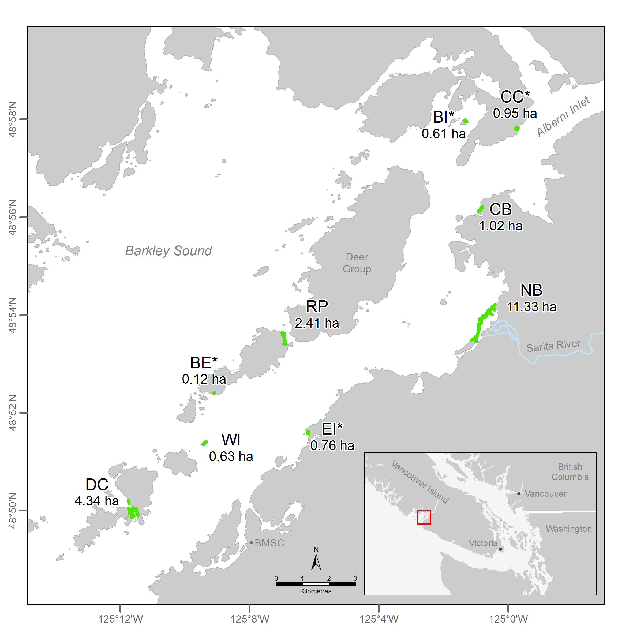

**B)**

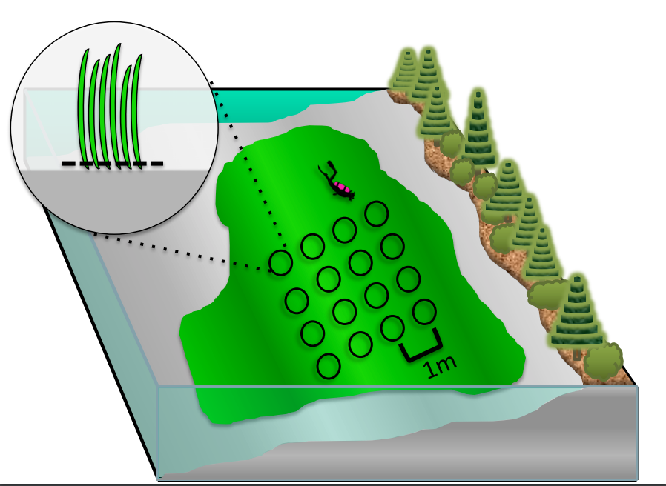

**Figure 2**: Fine-scale epifaunal diversity estimated from sampled plots (0.28 m2, n = 16) in nine eelgrass meadows in Trevor Channel, British Columbia, in midsummer 2012. Asterisks indicate significant differences (P < 0.01) among sites, based on a one-way ANOVA. Sites are arranged left to right in terms distance from a freshwater source, with DC being the most marine and farthest from a freshwater source (Figure 1).

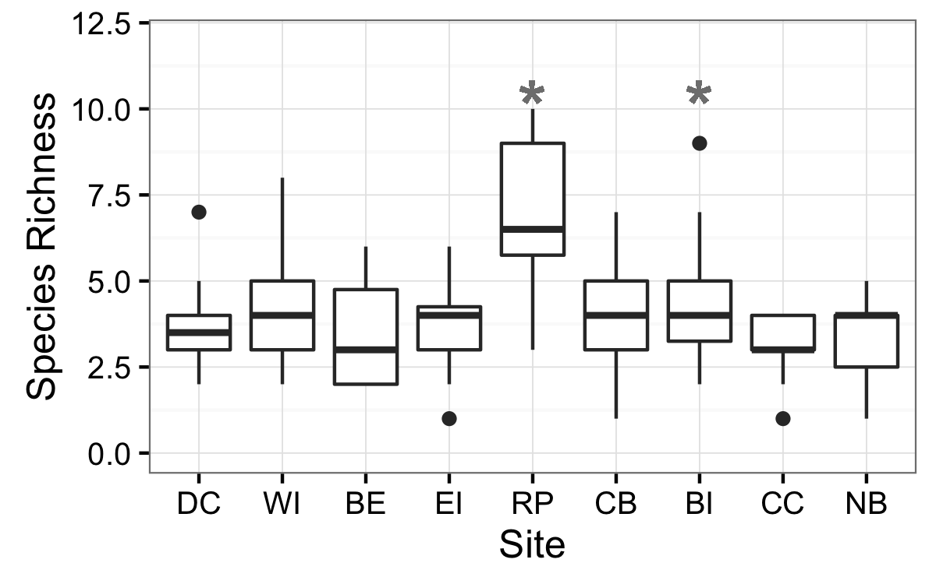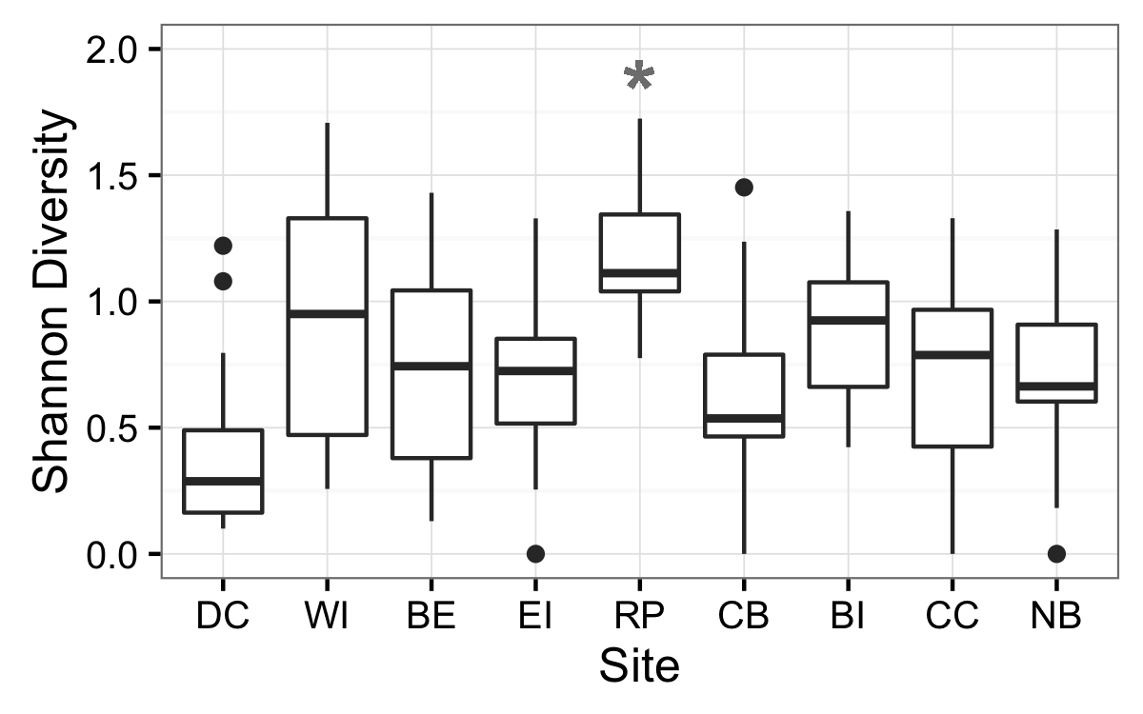

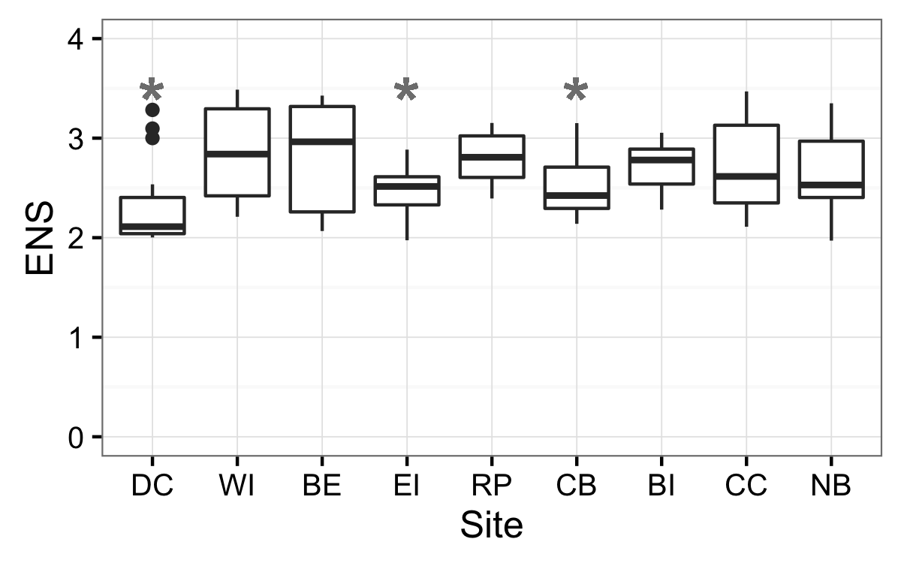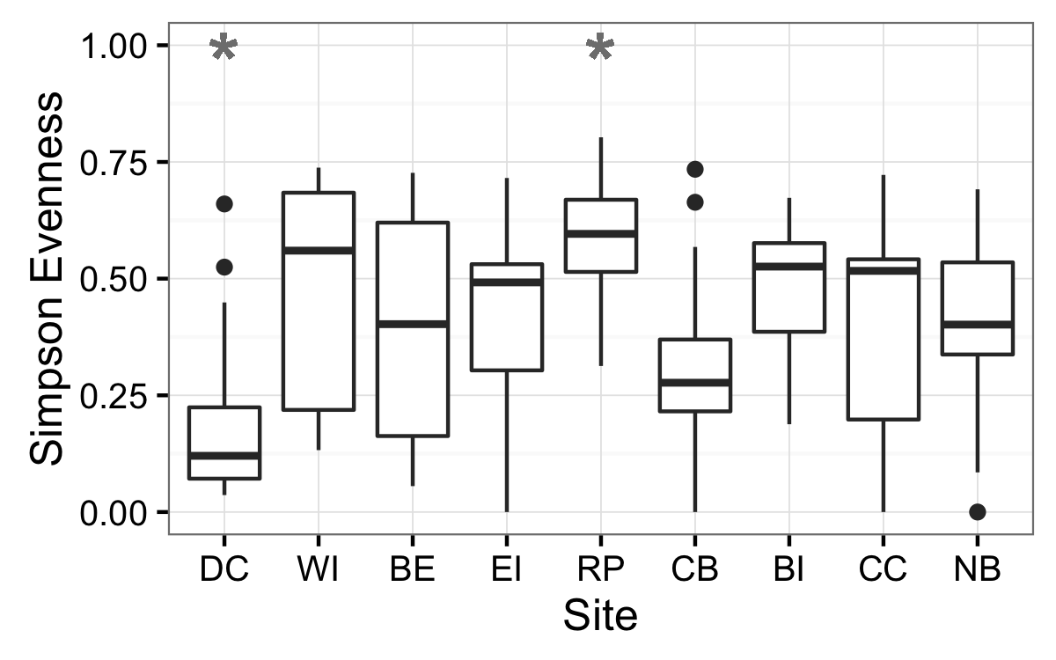

**Figure 3:** Temporal trends in rarified richness **(A)**, effective number of species **(B)**, shannon diversity **(C)**, simpson evenness **(D)**, and beta diversity as gamma/alpha **(E)** and mean Bray-Curtis distance **(F)** within all sites and time periods in May (“A”), June/July (“B”), and August (“C”). Site abbreviations as in Table 1.

**A)** **B)**

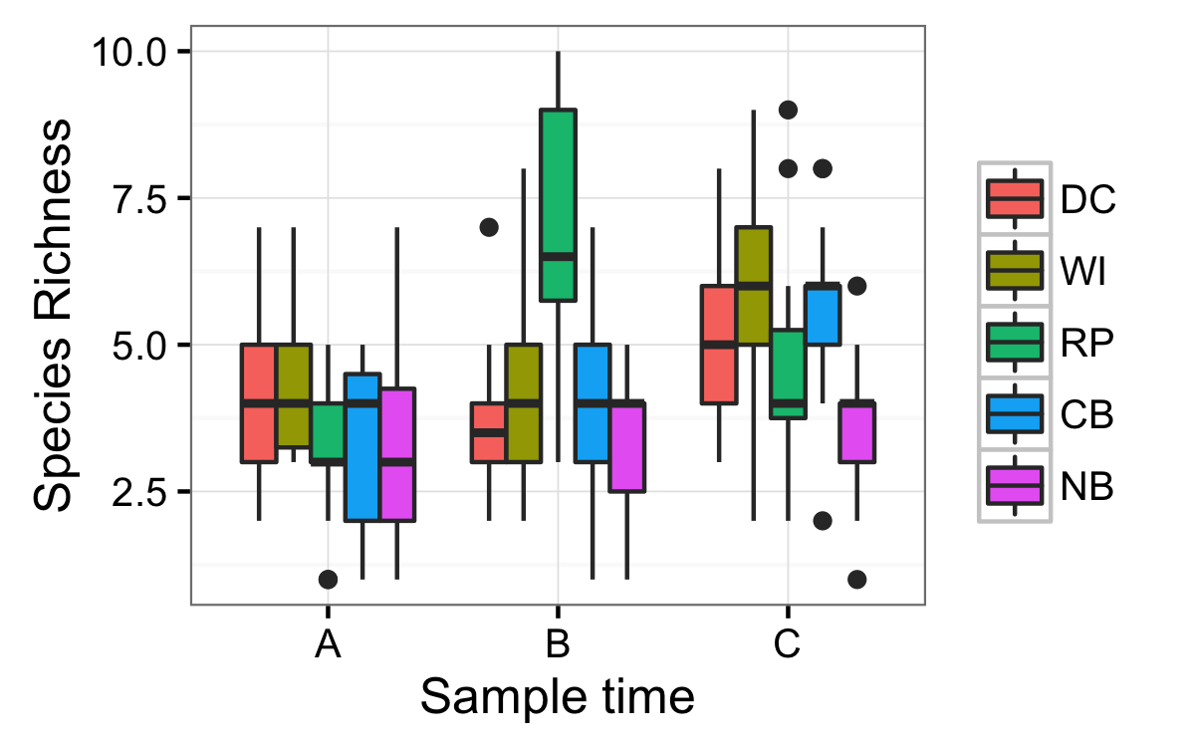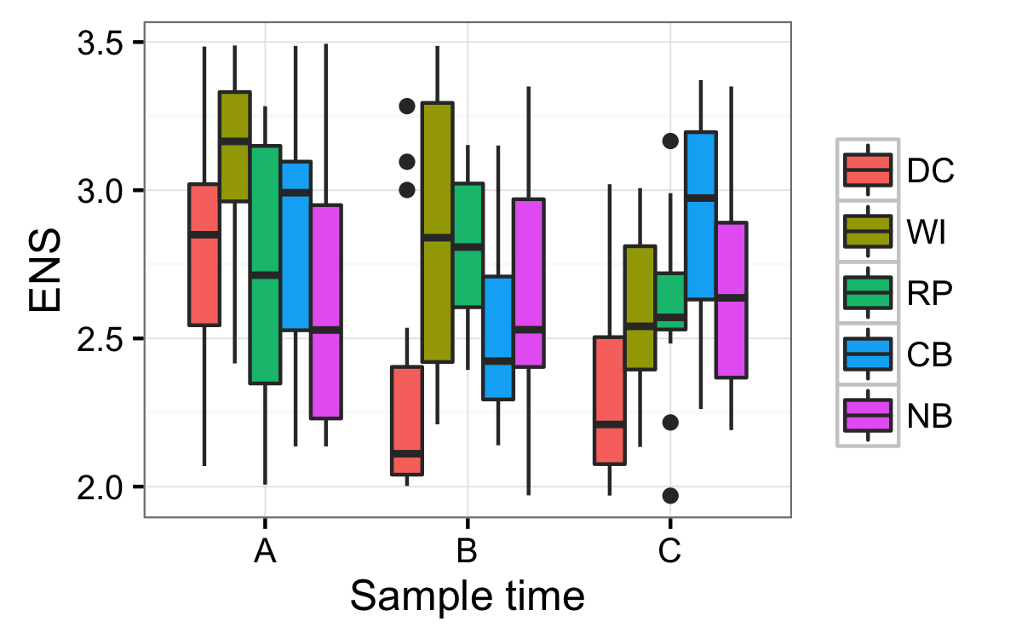

**C)** **D)**

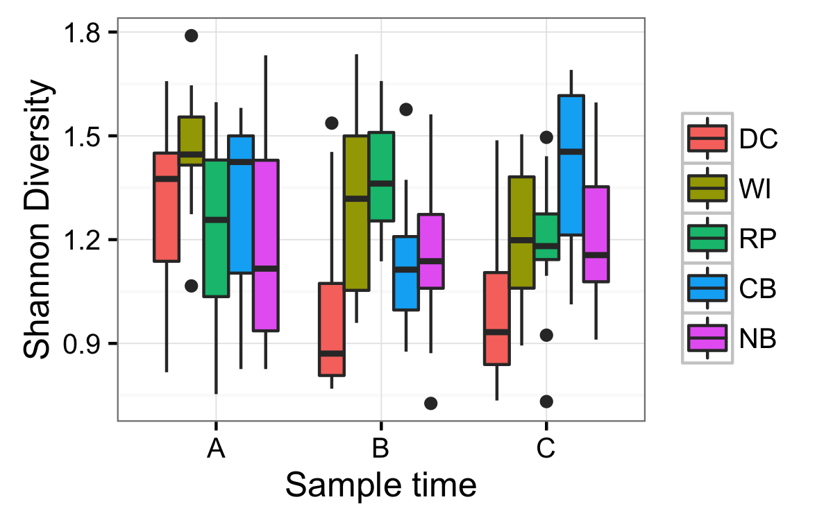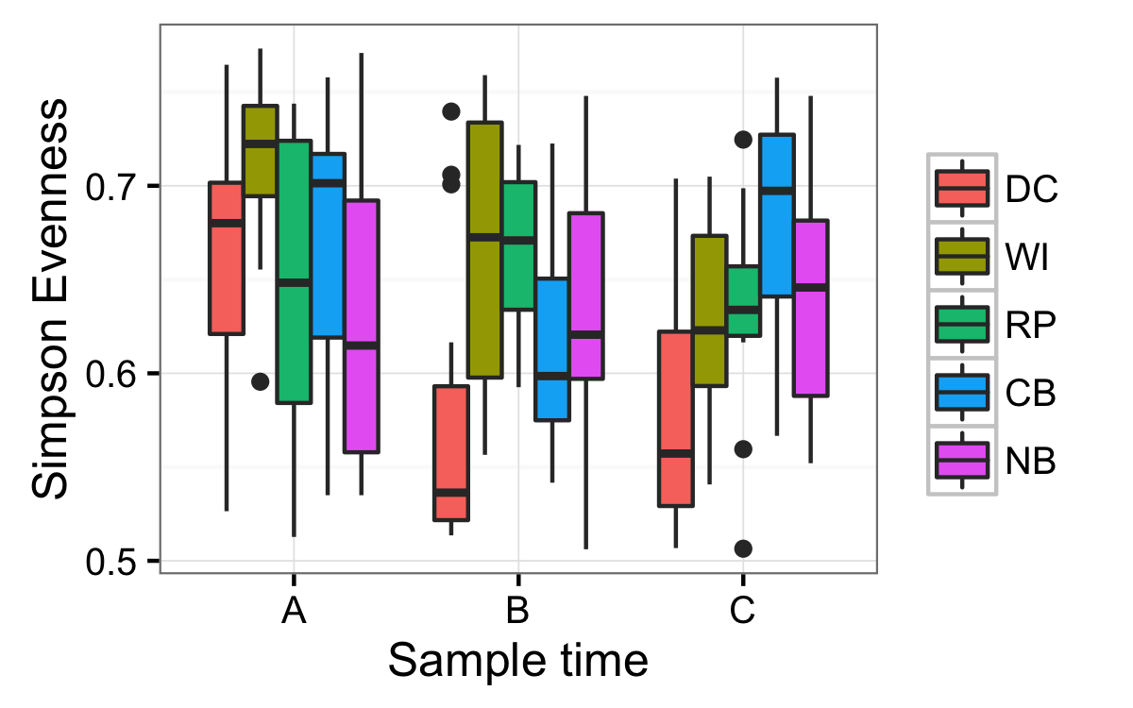

**E)**

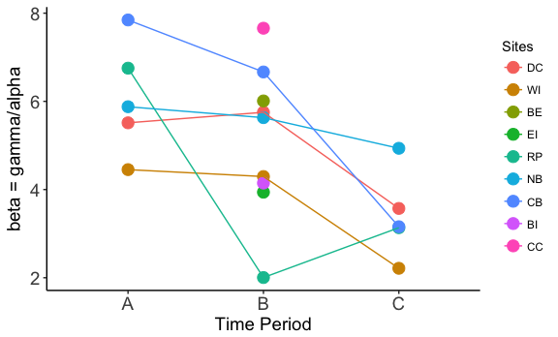

**F)**

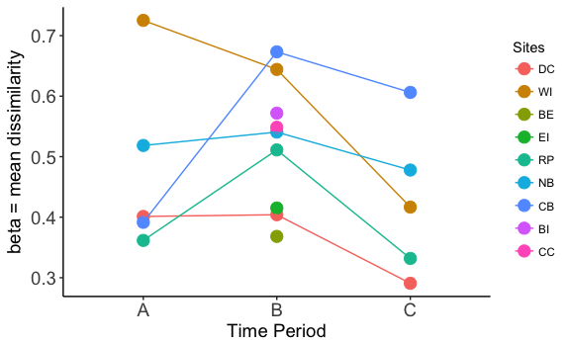

**Figure 4:** **A)** Beta diversity (species composition) within and among meadows varied less than expected. Expected beta diversity (rescaled Raup-Crick Probabilities, BRC) = 0, values approaching 1 show greater dissimilarity than null predictions, values approaching -1 show less dissimilarity than null predictions, with values at 0 being no different from the null predictions. Comparisons show among- and within-site probabilities for 5 (light green) and 9 (dark green) meadows. Comparisons across meadows pool all meadows within each sampling time, comparisons within meadows are pooled within each individual meadow. Box plots embedded with violin plots show median and quartiles, and width of violin plots show kernel probability density of those variables, with wider portions being more likely than narrower portions. **B)** nMDS of community composition and abundance in mid-summer across all sites using Bray-Curtis metric. 2-D stress = 0.23.

**A)**

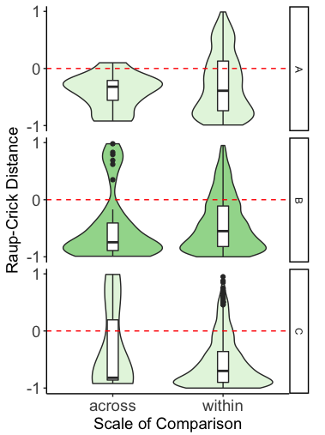

**B)**

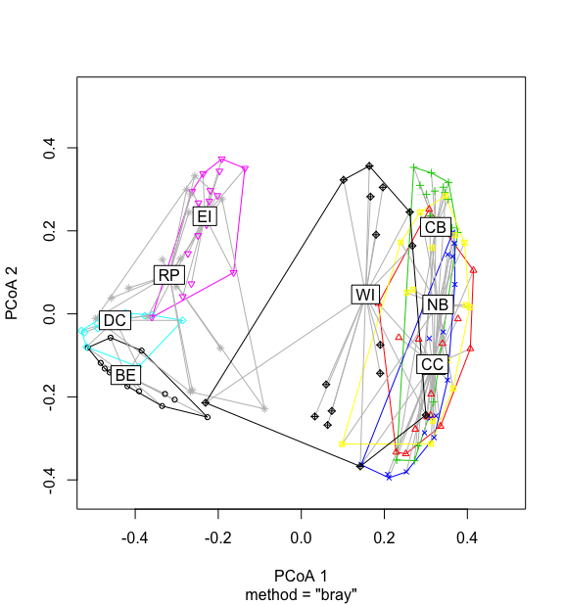

**Appendix**

**Table S1:** Model selection results for a set of candidate models predicting plot-level (n = 9) univariate richness indices across nine eelgrass meadows in July 2011. The top-ranked model is listed first in each group; models with delta > 2 are considered to have little support by the data.

|  |  |  |  |  |  |  |  |
| --- | --- | --- | --- | --- | --- | --- | --- |
| **Model** |  |  | **df** | **logLik** | **AICc** | **Delta** | **Wt** |
|  |  |  |  |  |  |  |  |
| Alpha |  |  |  |  |  |  |  |
|  |  |  |  |  |  |  |  |
|  | G | Y ~ site | 10 | -234.49 | 490.8 | 0 | 1 |
|  | D | Y ~ 1 | 2 | -262.61 | 529.3 | 38.46 | 0 |
|  | . | Y ~ area | 3 | -261.96 | 530.1 | 39.26 | 0 |
|  | B | Y ~ dfw | 3 | -262.25 | 530.7 | 39.83 | 0 |
|  | A | Y ~ fetch | 3 | -262.6 | 531.4 | 40.54 | 0 |
|  | C | Y ~ dfw*fetch | 5 | -262.23 | 534.9 | 44.1 | 0 |
|  | F | Y ~ area*fetch | 5 | -262.35 | 535.2 | 44.33 | 0 |
|  |  |  |  |  |  |  |  |
| H’ |  |  |  |  |  |  |  |
|  |  |  |  |  |  |  |  |
|  | G | Y ~ site | 10 | -51.28 | 124.4 | 0 | 0.999 |
|  | C | Y ~ dfw*fetch | 5 | -64.17 | 138.8 | 14.39 | 0.001 |
|  | B | Y ~ dfw | 3 | -67.36 | 140.9 | 16.48 | 0 |
|  | F | Y ~ area*fetch | 5 | -65.66 | 141.8 | 17.37 | 0 |
|  | A | Y ~ fetch | 3 | -68.52 | 143.2 | 18.8 | 0 |
|  | D | Y ~ 1 | 2 | -69.96 | 144 | 19.58 | 0 |
|  | . | Y ~ area | 3 | -69.69 | 145.6 | 21.15 | 0 |
|  |  |  |  |  |  |  |  |
| S |  |  |  |  |  |  |  |
|  |  |  |  |  |  |  |  |
|  | G | Y ~ site | 10 | 27.76 | -33.7 | 0 | 0.945 |
|  | C | Y ~ dfw*fetch | 5 | 18.67 | -26.9 | 6.81 | 0.031 |
|  | F | Y ~ area*fetch | 5 | 17.93 | -25.4 | 8.29 | 0.015 |
|  | B | Y ~ dfw | 3 | 14.96 | -23.7 | 9.94 | 0.007 |
|  | A | Y ~ fetch | 3 | 13.35 | -20.5 | 13.16 | 0.001 |
|  | D | Y ~ 1 | 2 | 11.63 | -19.2 | 14.5 | 0.001 |
|  | . | Y ~ area | 3 | 12.21 | -18.2 | 15.45 | 0 |
|  |  |  |  |  |  |  |  |
| ENS |  |  |  |  |  |  |  |
|  |  |  |  |  |  |  |  |
|  | G | Y ~ site | 10 | -52.19 | 126.2 | 0 | 0.628 |
|  | C | Y ~ dfw*fetch | 5 | -59.21 | 128.9 | 2.66 | 0.166 |
|  | F | Y ~ area*fetch | 5 | -59.78 | 130 | 3.8 | 0.094 |
|  | . | Y ~ area | 3 | -62.56 | 131.3 | 5.07 | 0.05 |
|  | B | Y ~ dfw | 3 | -63.13 | 132.4 | 6.2 | 0.022 |
|  | A | Y ~ fetch | 3 | -63.13 | 133.1 | 6.8 | 0.016 |
|  | D | Y ~ 1 | 2 | -64.88 | 133.9 | 7.62 | 0.011 |
|  |  |  |  |  |  |  |  |

**Table S2:** Mean shoot density and leaf area (cm2) with standard error (SE), and mean epiphyte load standardized as grams of epiphyte per gram of seagrass (dried weight) for patches of eelgrass meadow (0.28m2) sampled in May, July, and August 2012.

|  |  |  |  |  |  |  |
| --- | --- | --- | --- | --- | --- | --- |
|  | **Site** | **Mean Shoot Density** | **SE Shoot Density** | **Mean Leaf Area** | **SE Leaf Area** | **Mean Epiphtye Load** |
|  |  |  |  |  |  |  |
| May | DC | 12.3 | ±1.4 | 8037 | ±2229 | 0.02 |
| WI | 8 | ±2.3 | 3928 | ±1866 | 0.11 |
| RP | 7.7 | ±1.5 | 2245 | ±5 | 0.16 |
| NB | 6.5 | ±0.3 | 1593 | ±476 | 0.09 |
| CB | 4 | ±1.0 | 1903 | ±704 | 0.05 |
|  |  |  |  |  |  |  |
|  |  |  |  |  |  |  |
| July | DC | 14.8 | ±2.0 | 9257 | ±1493 | 0.07 |
| WI | 12.5 | ±1.8 | 5608 | ±1223 | 0.15 |
| BE | 7 | ±1.5 | 2542 | ±787 | 0.04 |
| EI | 12.5 | ±1.2 | 6246 | ±1078 | 0.03 |
| RP | 10.3 | ±1.8 | 4372 | ±1576 | 0.04 |
| NB | 8.3 | ±3.1 | 5062 | ±2285 | 0.09 |
| CB | 6.5 | ±0.9 | 2885 | ±381 | 0.04 |
| BI | 5.5 | ±1.4 | 2811 | ±1315 | 0.05 |
| CC | 6 | ±2.2 | 3576 | ±1736 | 0.02 |
|  |  |  |  |  |  |  |
|  |  |  |  |  |  |  |
| August | DC | 12.7 | ±1.9 | 7902 | ±1213 | 0.01 |
| WI | 7.8 | ±1.8 | 4611 | ±392 | 0.08 |
| RP | 8 | ±1.8 | 4514 | ±781 | 0.03 |
| NB | 9.5 | ±0.6 | 4302 | ±1216 | 0.06 |
| CB | 7.3 | ±1.1 | 3562 | ±537 | 0.02 |
|  |  |  |  |  |  |  |

**Table S3:** Model results for tests of relationships between abiotic and biotic meadow attributes. In all models, intercepts wre allowed to vary randomly among meadows.

|  |  |  |  |  |  |  |
| --- | --- | --- | --- | --- | --- | --- |
| **Model** |  | **df** | **logLik** | **AICc** | **Delta** | **Wt** |
|  |  |  |  |  |  |  |
| Salinity |  |  |  |  |  |  |
|  |  |  |  |  |  |  |
|  | **Y ~ dfw** | **4** | **-418.12** | **844.5** | **0** | **0.629** |
|  | **Y ~ temp+dfw** | **5** | **-417.64** | **845.7** | **1.18** | **0.343** |
|  | Y ~ temp*dfw | 6 | -419.04 | 850.7 | 6.17 | 0.028 |
|  | Y ~ temp | 4 | -422.87 | 854.0 | 9.50 | 0.005 |
|  | Y ~ 1 | 3 | -424.32 | 854.8 | 10.27 | 0.004 |
|  | Y ~ temp+dfw+fetch | 6 | -428.54 | 869.7 | 25.16 | 0.000 |
|  | Y ~ fetch | 4 | -434.09 | 876.5 | 31.94 | 0.000 |
|  |  |  |  |  |  |  |
| Temperature |  |  |  |  |  |  |
|  |  |  |  |  |  |  |
|  | **Y ~ dfw** | **4** | **-328.31** | **664.9** | **0** | **0.434** |
|  | **Y ~ 1** | **3** | **-329.69** | **665.5** | **0.64** | **0.315** |
|  | **Y ~ Sal** | **4** | **-329.23** | **666.7** | **1.84** | **0.173** |
|  | Y ~ Sal + dfw | 5 | -328.97 | 668.4 | 3.47 | 0.076 |
|  | Y ~ Sal*dfw | 6 | -332.06 | 676.7 | 11.83 | 0.001 |
|  | Y ~ fetch | 4 | -340.49 | 689.3 | 24.35 | 0.000 |
|  | Y ~ Sal+dfw+fetch | 6 | -340.05 | 692.7 | 27.80 | 0.000 |
|  |  |  |  |  |  |  |

**Table S3:** Coefficients from best models (mod) from linear regression analyses testing for variation in abiotic and biotic meadow properties with sampling date and position in the watershed. Model coefficients and 95% confidence intervals for best models for meadow-scale characteristics. Res. = median residual values. Bold values indicate coefficients for which confidence intervals do not include 0.

> summary(mod.sal)

Call:

model.avg(object = mod5, mod2)

Model-averaged coefficients:

(full average)

Estimate Std. Error Adjusted SE z value Pr(>|z|)

(Intercept) 15.36650 2.89873 2.90924 5.282 1.0e-07 ***

dfw 0.53998 0.09569 0.11415 4.730 2.2e-06 ***

Temp.a -0.09405 0.15699 0.15750 0.597 0.55

(conditional average)

Estimate Std. Error Adjusted SE z value Pr(>|z|)

(Intercept) 15.36650 2.89873 2.90924 5.282 1.30e-07 ***

dfw 0.53998 0.09569 0.11415 4.730 2.24e-06 ***

Temp.a -0.26375 0.15608 0.15750 1.675 0.094 .

---

Signif. codes: 0 ‘***’ 0.001 ‘**’ 0.01 ‘*’ 0.05 ‘.’ 0.1 ‘ ’ 1

> confint(mod.sal)

2.5 % 97.5 %

(Intercept) 9.6645071 21.06850133

dfw 0.3162454 0.76371689

Temp.a -0.5724456 0.04494624

TEMPERATURE

> model.avg(mod5, mod4, mod1) -> mod.t

> summary(mod.t)

Call:

model.avg(object = mod5, mod4, mod1)

Component model call:

lme.formula(fixed = <3 unique values>, data = sites2, random = ~1 | Site, na.action =

na.omit)

Component models:

df logLik AICc delta weight

1 4 -328.31 664.90 0.00 0.47

(Null) 3 -329.69 665.54 0.64 0.34

2 4 -329.23 666.74 1.84 0.19

Term codes:

dfw Sal.a

1 2

Model-averaged coefficients:

(full average)

Estimate Std. Error Adjusted SE z value Pr(>|z|)

(Intercept) 17.38510 0.92148 0.92458 18.803 <2e-16 ***

dfw -0.09324 0.10884 0.11306 0.825 0.410

Sal.a -0.01907 0.04367 0.04374 0.436 0.663

(conditional average)

Estimate Std. Error Adjusted SE z value Pr(>|z|)

(Intercept) 17.38510 0.92148 0.92458 18.803 <2e-16 ***

dfw -0.19829 0.06606 0.07970 2.488 0.0129 *

Sal.a -0.10152 0.04221 0.04259 2.384 0.0171 *

---

Signif. codes: 0 ‘***’ 0.001 ‘**’ 0.01 ‘*’ 0.05 ‘.’ 0.1 ‘ ’ 1

Relative variable importance:

dfw Sal.a

Importance: 0.47 0.19

N containing models: 1 1

> confint(mod.t)

2.5 % 97.5 %

(Intercept) 15.5729572 19.19723349

dfw -0.3545052 -0.04206887

Sal.a -0.1850024 -0.01804583

**Table S4:** Mean epiphyte loads ± standard error at the three sites in June (period B) and August (period C) 2012. Epiphyte load is standardized to seagrass dry weight in grams. Bladed epiphytes are *Punctaria* sp.

|  |  |  |  |  |  |  |
| --- | --- | --- | --- | --- | --- | --- |
| **Site** | **Bladed epiphyte load** | | | **Periphyton load** | | |
|  |  |  |  | |  |
|  | Jun | Aug | Jun | | Aug |
|  |  |  |  | |  |
| DC | 0.45 ± 0.05 (14) | 0.15  (1) | 0.56 ± 0.06 (15) | | 0.56 ± 0.05 (15) |
| WI | 0.04 ± 0.03 (7) | 0.43 ± 0.12 (13) | 0.61 ± 0.07 (15) | | 0.57 ± 0.04 (15) |
| NB | -- | 0.12  (1) | 0.87 ± 0.08 (15) | | 1.05 ± 0.12 (15) |
|  |  |  |  | |  |

**Table S5:** Mean summer temperature and salinity values (May – August 2012) with standard error (SE).

|  |  |  |  |  |
| --- | --- | --- | --- | --- |
| **Site** | **Mean Temperature** | **SE Temperature** | **Mean Salinity** | **SE Salinity** |
|  |  |  |  |  |
| DC | 12.6 | ±0.2 | 25.7 | ±0.6 |
| WI | 13.7 | ±0.2 | 21.7 | ±0.5 |
| RP | 14.1 | ±0.3 | 22.4 | ±0.4 |
| NB | 14.9 | ±0.4 | 16.6 | ±0.5 |
| CB | 14.8 | ±0.5 | 17.3 | ±0.5 |
|  |  |  |  |  |

**Table S6**: Values of beta diversity within each site per time period expressed as gamma/mean alpha, and mean Bray-Curtis dissimilarity

|  |  |  |  |  |  |  |  |  |  |
| --- | --- | --- | --- | --- | --- | --- | --- | --- | --- |
| **Site** |  | **Beta (gamma/alpha)** | | |  | **Beta (Bray-Curtis)** | | | |
|  |  |  |  |  |  |  |  |  |
|  |  | A | B | C |  | A | B | C |
|  |  |  |  |  |  |  |  |  |
| DC |  | 5.5133 | 5.7523 | 3.5714 |  | 0.4012 | 0.4041 | 0.2908 |
| WI |  | 4.4519 | 4.295 | 2.214 |  | 0.7253 | 0.6442 | 0.4167 |
| BE |  | NA | 6.0095 | NA |  | NA | 0.3683 | NA |
| EI |  | NA | 3.9396 | NA |  | NA | 0.4152 | NA |
| RP |  | 6.7528 | 2.0041 | 3.1348 |  | 0.3616 | 0.5112 | 0.3318 |
| NB |  | 5.8785 | 5.6306 | 4.9355 |  | 0.5185 | 0.5407 | 0.4779 |
| CB |  | 7.8462 | 6.6667 | 3.1566 |  | 0.3915 | 0.6733 | 0.6062 |
| BI |  | NA | 4.1469 | NA |  | NA | 0.5719 | NA |
| CC |  | NA | 7.6588 | NA |  | NA | 0.5486 | NA |
|  |  |  |  |  |  |  |  |  |

**Table S7**: Mean abundance of epifauna and standard error per 0.28m2 plot across all sites and sample periods.

|  |  |  |  |
| --- | --- | --- | --- |
|  | **Site** | **Mean Abundance** | **Error** |
|  |  |  |  |
| May | DC | 67.75 | ±7.18 |
| WI | 26.19 | ±6.68 |
| RP | 60.20 | ±7.66 |
| NB | 41.88 | ±4.77 |
| CB | 26.25 | ±3.28 |
|  |  |  |  |
|  |  |  |  |
| July | DC | 515.94 | ±89.63 |
| WI | 78.18 | ±14.18 |
| BE | 102.31 | ±14.11 |
| EI | 542.25 | ±90.16 |
| RP | 376.81 | ±78.24 |
| NB | 130.56 | ±26.64 |
| CB | 124.81 | ±19.11 |
| BI | 101.63 | ±23.59 |
| CC | 45.25 | ±7.63 |
|  |  |  |  |
|  |  |  |  |
| August | DC | 1181.31 | ±114.45 |
| WI | 600.06 | ±112.25 |
| RP | 860.75 | ±116.97 |
| NB | 94.13 | ±17.42 |
| CB | 121.73 | ±26.13 |
|  |  |  |  |

**FIGURE S1:** Beta diversity (species composition) within and among meadows varied less than expected. Expected beta diversity (rescaled Raup-Crick Probabilities, BRC) = 0, values approaching 1 show greater dissimilarity than null predictions, values approaching -1 show less dissimilarity than null predictions, with values at 0 being no different from the null predictions. Comparisons show among-site probabilities for 9 meadows over the course of summer 2012 (May = A, June/July = B, August = C). Box plots embedded with violin plots show median and quartiles, and width of violin plots show kernel probability density of those variables, with wider portions being more likely than narrower portions.

